**Note:**

* The assignment is designed to practice constructor, getter/setter and toString method.
* Create a separate project for each question and create separate file for each class.
* Try to test the functionality by using menu-driven program.

**1. Loan Amortization Calculator**

Implement a system to calculate and display the monthly payments for a mortgage loan. The system should:

1. Accept the principal amount (loan amount), annual interest rate, and loan term (in years) from the user.
2. Calculate the monthly payment using the standard mortgage formula:
   * **Monthly Payment Calculation:**
     + monthlyPayment = principal * (monthlyInterestRate * (1 + monthlyInterestRate)^(numberOfMonths)) / ((1 + monthlyInterestRate)^(numberOfMonths) - 1)
     + Where monthlyInterestRate = annualInterestRate / 12 / 100 and numberOfMonths = loanTerm * 12
     + Note: Here ^ means power and to find it you can use Math.pow( ) method
3. Display the monthly payment and the total amount paid over the life of the loan, in Indian Rupees (₹).

Define the class LoanAmortizationCalculator with fields, an appropriate constructor, getter and setter methods, a toString method and business logic methods. Define the class LoanAmortizationCalculatorUtil with methods acceptRecord, printRecord, and menuList. Define the class Program with a main method and test the functionality of the utility class.

Solution:

1. LoanAmortizationCalculator

**package** Program.org;

**public** **class** LoanAmortizationCalculator {

**private** **double** loanAmount;

**private** **double** annualInterestRate;

**private** **int** loanTerm;

**public** **double** getLoanAmount() {

**return** loanAmount;

}

**public** **void** setLoanAmount(**double** loanAmount) {

**this**.loanAmount = loanAmount;

}

**public** **double** getAnnualInterestRate() {

**return** annualInterestRate;

}

**public** **void** setAnnualInterestRate(**double** annualInterestRate) {

**this**.annualInterestRate = annualInterestRate;

}

**public** **int** getLoanTerm() {

**return** loanTerm;

}

**public** **void** setLoanTerm(**int** loanTerm) {

**this**.loanTerm = loanTerm;

}

@Override

**public** String toString() {

String res = "LoanAmortizationCalculator [loanAmount=" + loanAmount + ", annualInterestRate=" + annualInterestRate

+ ", loanTerm=" + loanTerm + "]";

res = res + "monthly payment" + calculateMonthlyPayment(**this**.loanAmount, **this**.annualInterestRate, **this**.loanTerm);

**return** res;

}

**public** **double** calculateMonthlyPayment(**double** loanAmount, **double** annualInterestRate, **int** loanTerm) {

**int** numberOfMonths = loanTerm * 12;

**double** monthlyInterestRate = annualInterestRate / 12 / 100;

**double** monthlyPayment = (loanAmount * Math.*pow*(1 + monthlyInterestRate , numberOfMonths)) / ((Math.*pow*(1 + monthlyInterestRate, numberOfMonths) - 1));

**return** monthlyPayment;

}

}

2. LoanAmortizationCalculatorUtil.

**package** Program.org;

**import** java.util.Scanner;

**public** **class** LoanAmortizationCalculatorUtil {

**private** Scanner sc;

**public** LoanAmortizationCalculatorUtil() {

sc = **new** Scanner(System.***in***);

}

**public** **void** menuList() {

System.***out***.println("Enter choice 1. Accept and print record , 2. To exit");

**int** choice = sc.nextInt();

**switch** (choice) {

**case** 1:

acceptRecord();

**break**;

**case** 2:

**return**;

**default**:

System.***out***.println("wrong choice");

**break**;

}

}

**private** **void** acceptRecord() {

LoanAmortizationCalculator loan = **new** LoanAmortizationCalculator();

System.***out***.println("enter loan amount, interest rate, and term");

**double** amount = sc.nextDouble();

loan.setLoanAmount(amount);

**double** rate = sc.nextDouble();

loan.setAnnualInterestRate(rate);

**int** term = sc.nextInt();

loan.setLoanTerm(term);

System.***out***.println(loan.toString());

}

}

3.Program.java

**package** Program.org;

**public** **class** Program {

**public** **static** **void** main(String[] args) {

LoanAmortizationCalculatorUtil loan = **new** LoanAmortizationCalculatorUtil();

loan.menuList();

}

}

Output:

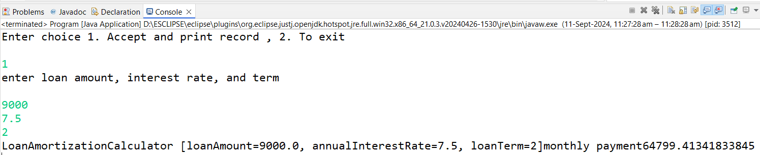

**2. Compound Interest Calculator for Investment**

Develop a system to compute the future value of an investment with compound interest. The system should:

1. Accept the initial investment amount, annual interest rate, number of times the interest is compounded per year, and investment duration (in years) from the user.
2. Calculate the future value of the investment using the formula:
   * **Future Value Calculation:**
     + futureValue = principal * (1 + annualInterestRate / numberOfCompounds)^(numberOfCompounds * years)
   * **Total Interest Earned:** totalInterest = futureValue - principal
3. Display the future value and the total interest earned, in Indian Rupees (₹).

Define the class CompoundInterestCalculator with fields, an appropriate constructor, getter and setter methods, a toString method and business logic methods. Define the class CompoundInterestCalculatorUtil with methods acceptRecord, printRecord, and menuList. Define the class Program with a main method to test the functionality of the utility class.

Solution:

1. Compound Interest Calculator

package exe.java;

class CompoundInterestCalculator {

private double principal;

private double annualInterestRate;

private int numberOfCompounds;

private int years;

// Default Constructor

public CompoundInterestCalculator() {}

// Parameterized Constructor

public CompoundInterestCalculator(double principal, double annualInterestRate, int numberOfCompounds, int years) {

this.principal = principal;

this.annualInterestRate = annualInterestRate;

this.numberOfCompounds = numberOfCompounds;

this.years = years;

}

// Getters and Setters

public double getPrincipal() {

return principal;

public void setPrincipal(double principal) {

this.principal = principal;

}

public double getAnnualInterestRate() {

return annualInterestRate;

}

public void setAnnualInterestRate(double annualInterestRate) {

this.annualInterestRate = annualInterestRate;

}

public int getNumberOfCompounds() {

return numberOfCompounds;

}

public void setNumberOfCompounds(int numberOfCompounds) {

this.numberOfCompounds = numberOfCompounds;

}

public int getYears() {

return years;

public void setYears(int years) {

this.years = years;

}

// Method to calculate future value

public double calculateFutureValue() {

return principal * Math.*pow*(1 + (annualInterestRate / numberOfCompounds), numberOfCompounds * years);

// Method to calculate total interest earned

public double calculateTotalInterest() {

return calculateFutureValue() - principal;

}

@Override

public String toString() {

return String.*format*("Investment Details:\nPrincipal: ₹%.2f\nAnnual Interest Rate: %.2f%%\n" +

"Compounds per Year: %d\nInvestment Duration: %d years",

principal, annualInterestRate, numberOfCompounds, years);

}

**}**

1. CompoundInterestUtil.java

Package exe.java;

**import** java.util.Scanner;

**class** CompoundInterestCalculatorUtil {

Scanner scanner = **new** Scanner(System.***in***);

**private** CompoundInterestCalculator compoundInterestCalculator;

**public** **void** acceptRecord() {

System.***out***.print("Enter Initial Investment Amount (in ₹): ");

**double** principal = scanner.nextDouble();

System.***out***.print("Enter Annual Interest Rate (in %): ");

**double** annualInterestRate = scanner.nextDouble();

System.***out***.print("Enter Number of Compounds per Year: ");

**int** numberOfCompounds = scanner.nextInt();

System.***out***.print("Enter Investment Duration (in years): ");

**int** years = scanner.nextInt();

compoundInterestCalculator = **new** CompoundInterestCalculator(principal, annualInterestRate, numberOfCompounds, years);

}

**public** **void** printRecord() {

System.***out***.println(compoundInterestCalculator); // Display investment details

**double** futureValue = compoundInterestCalculator.calculateFutureValue();

**double** totalInterest = compoundInterestCalculator.calculateTotalInterest();

System.***out***.printf("Future Value: ₹%.2f\n", futureValue);

System.***out***.printf("Total Interest Earned: ₹%.2f\n", totalInterest);

}

// Method to display the menu options

**public** **void** menuList() {

System.***out***.println("1. Enter Investment Details");

System.***out***.println("2. Display Future Value and Total Interest");

System.***out***.println("3. Exit");

}

}

1. Program.java (Main Method)

**package** exe.java;

**import** java.util.Scanner;

**public** **class** Program {

**public** **static** **void** main(String[] args) {

CompoundInterestCalculatorUtil util = **new** CompoundInterestCalculatorUtil();

Scanner scanner = **new** Scanner(System.***in***);

**int** choice;

**do** {

util.menuList();

System.***out***.print("Enter your choice: ");

choice = scanner.nextInt();

**switch** (choice) {

**case** 1:

util.acceptRecord(); // Accept investment details from user

**break**;

**case** 2:

util.printRecord(); // Display future value and total interest

**break**;

**case** 3:

System.***out***.println("Exiting...");

**break**;

**default**:

System.***out***.println("Invalid choice! Please select a valid option.");

}

} **while** (choice != 3); // Repeat menu until user selects "Exit"

scanner.close();

}

}

Output:

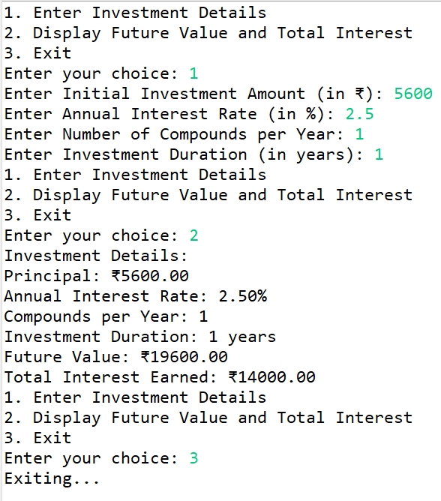

**3. BMI (Body Mass Index) Tracker**

Create a system to calculate and classify Body Mass Index (BMI). The system should:

1. Accept weight (in kilograms) and height (in meters) from the user.
2. Calculate the BMI using the formula:
   * **BMI Calculation:** BMI = weight / (height * height)
3. Classify the BMI into one of the following categories:
   * Underweight: BMI < 18.5
   * Normal weight: 18.5 ≤ BMI < 24.9
   * Overweight: 25 ≤ BMI < 29.9
   * Obese: BMI ≥ 30
4. Display the BMI value and its classification.

Define the class BMITracker with fields, an appropriate constructor, getter and setter methods, a toString method, and business logic methods. Define the class BMITrackerUtil with methods acceptRecord, printRecord, and menuList. Define the class Program with a main method to test the functionality of the utility class.

Solution:

1. BMI (Body Mass Index) Tracker

**package** exe.java;

**import** java.util.Scanner;

**public** **class** Program {

**public** **static** **void** main(String[] args) {

Scanner sc = **new** Scanner(System.***in***);

BMITrackerrUtil util = **new** BMITrackerrUtil();

BMITrackerr tracker = **null**;

**int** choice;

**do** {

util.menuList();

System.***out***.print("Enter your choice: ");

choice = sc.nextInt();

**switch** (choice) {

**case** 1:

tracker = util.acceptRecord(); // Accept new record

util.printRecord(tracker); // Display the calculated BMI

**break**;

**case** 2:

util.printRecord(tracker); // Display the last BMI record

**break**;

**case** 3:

System.***out***.println("Exiting...");

**break**;

**default**:

System.***out***.println("Invalid choice, please try again.");

}

} **while** (choice != 3);

sc.close();

}

}

1. BMITracker.util

package exe.java;

import java.util.Scanner;

public class BMITrackerrUtil {

private Scanner sc = new Scanner(System.*in*);

public BMITrackerr acceptRecord() {

System.*out*.print("Enter weight : ");

double weight = sc.nextDouble();

System.*out*.print("Enter height : ");

double height = sc.nextDouble();

return new BMITrackerr(weight, height);

}

public void printRecord(BMITrackerr tracker) {

System.*out*.println(tracker);

}

// Method to display the menu

public void menuList() {

System.*out*.println("1. Calculate BMI");

System.*out*.println("2. Display Last BMI Record");

System.*out*.println("3. Exit");

}

}

1. Program.java

package exe.java;

import java.util.Scanner;

public class Program {

public static void main(String[] args) {

Scanner sc = new Scanner(System.*in*);

BMITrackerrUtil util = new BMITrackerrUtil();

BMITrackerr tracker = null;

int choice;

do {

util.menuList();

System.*out*.print("Enter your choice: ");

choice = sc.nextInt();

switch (choice) {

case 1:

tracker = util.acceptRecord(); // Accept new record

util.printRecord(tracker); // Display the calculated BMI

break;

case 2:

util.printRecord(tracker); // Display the last BMI record

break;

case 3:

System.*out*.println("Exiting...");

break;

default:

System.*out*.println("Invalid choice, please try again.");

}

} while (choice != 3);

sc.close();

}

}

Output:

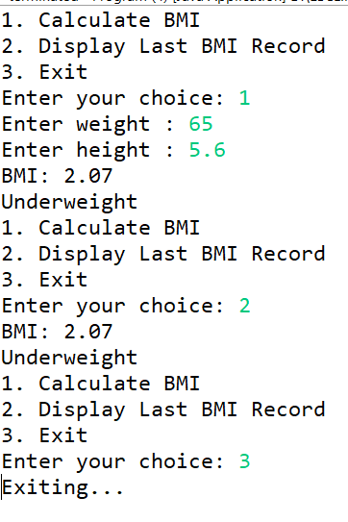

**4. Discount Calculation for Retail Sales**

Design a system to calculate the final price of an item after applying a discount. The system should:

1. Accept the original price of an item and the discount percentage from the user.
2. Calculate the discount amount and the final price using the following formulas:
   * **Discount Amount Calculation:** discountAmount = originalPrice * (discountRate / 100)
   * **Final Price Calculation:** finalPrice = originalPrice - discountAmount
3. Display the discount amount and the final price of the item, in Indian Rupees (₹).

Define the class DiscountCalculator with fields, an appropriate constructor, getter and setter methods, a toString method, and business logic methods. Define the class DiscountCalculatorUtil with methods acceptRecord, printRecord, and menuList. Define the class Program with a main method to test the functionality of the utility class.

Solution:

1. DiscountCalculator

**package** program.java;

**public** **class** DiscountCalculator {

**private** **double** originalPrice;

**private** **double** discountRate;

**private** **double** discountAmount;

**private** **double** finalPrice;

// Constructor

**public** DiscountCalculator(**double** originalPrice, **double** discountRate) {

**this**.originalPrice = originalPrice;

**this**.discountRate = discountRate;

calculateDiscount();

}

**public** **double** getOriginalPrice() {

**return** originalPrice;

}

**public** **void** setOriginalPrice(**double** originalPrice) {

**this**.originalPrice = originalPrice;

}

**public** **double** getDiscountRate() {

**return** discountRate;

}

**public** **void** setDiscountRate(**double** discountRate) {

**this**.discountRate = discountRate;

}

**public** **double** getDiscountAmount() {

**return** discountAmount;

}

**public** **double** getFinalPrice() {

**return** finalPrice;

}

//logic to calculate discount and final price

**private** **void** calculateDiscount() {

discountAmount = originalPrice * (discountRate / 100);

finalPrice = originalPrice - discountAmount;

}

@Override

**public** String toString() {

**return** String.*format*("Original Price: ₹%.2f\nDiscount Rate: %.2f%%\nDiscount Amount: ₹%.2f\nFinal Price: ₹%.2f",

originalPrice, discountRate, discountAmount, finalPrice);

}

}

1. DiscountCalculatorUtil.

**package** program.java;

**import** java.util.Scanner;

**public** **class** DiscountCalculatorUtil {

**private** **static** DiscountCalculator *lastRecord*;

**public** **static** **void** acceptRecord(Scanner scanner) {

System.***out***.print("Enter original price: ₹");

**double** originalPrice = scanner.nextDouble();

System.***out***.print("Enter discount percentage: ");

**double** discountRate = scanner.nextDouble();

*lastRecord* = **new** DiscountCalculator(originalPrice, discountRate); // Create new record

System.***out***.println("Discount calculation completed!");

}

**public** **static** **void** printRecord() {

System.***out***.println(*lastRecord*); // Use toString() of DiscountCalculator

}

// Method to display menu options

**public** **static** **void** menuList() {

System.***out***.println("Discount Calculator Menu:");

System.***out***.println("1. Calculate Discount");

System.***out***.println("2. Display Last Discount");

System.***out***.println("3. Exit");

}

}

1. Program.java (main program)

**package** program.java;

**import** java.util.Scanner;

**public** **class** Program {

**public** **static** **void** main(String[] args) {

Scanner scanner = **new** Scanner(System.***in***);

**int** choice;

**do** {

DiscountCalculatorUtil.*menuList*();

System.***out***.print("Enter your choice: ");

choice = scanner.nextInt();

**switch** (choice) {

**case** 1:

DiscountCalculatorUtil.*acceptRecord*(scanner);

**break**;

**case** 2:

DiscountCalculatorUtil.*printRecord*();

**break**;

**case** 3:

System.***out***.println("Exiting...");

**break**;

**default**:

System.***out***.println("Invalid choice! Please try again.");

**break**;

}

} **while** (choice != 3);

scanner.close();

}

}

Output:

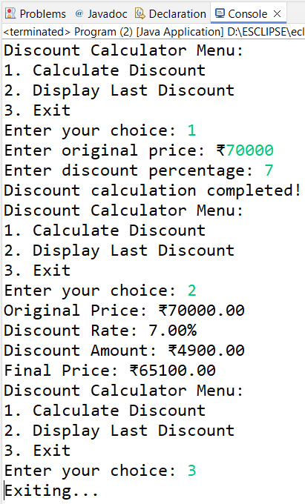

**5. Toll Booth Revenue Management**

Develop a system to simulate a toll booth for collecting revenue. The system should:

1. Allow the user to set toll rates for different vehicle types: Car, Truck, and Motorcycle.
2. Accept the number of vehicles of each type passing through the toll booth.
3. Calculate the total revenue based on the toll rates and number of vehicles.
4. Display the total number of vehicles and the total revenue collected, in Indian Rupees (₹).

* **Toll Rate Examples:**
  + Car: ₹50.00
  + Truck: ₹100.00
  + Motorcycle: ₹30.00

Define the class TollBoothRevenueManager with fields, an appropriate constructor, getter and setter methods, a toString method, and business logic methods. Define the class TollBoothRevenueManagerUtil with methods acceptRecord, printRecord, and menuList. Define the class Program with a main method to test the functionality of the utility class.

Solution:

1. TollBooth

**package** exe.java;

**public** **class** TollBooth{

**private** **double** carRate;

**private** **double** truckRate;

**private** **double** motorcycleRate;

**private** **int** carCount;

**private** **int** truckCount;

**private** **int** motorcycleCount;

// Constructor

**public** TollBooth(**double** carRate, **double** truckRate, **double** motorcycleRate) {

**this**.carRate = carRate;

**this**.truckRate = truckRate;

**this**.motorcycleRate = motorcycleRate;

**this**.carCount = 0;

**this**.truckCount = 0;

**this**.motorcycleCount = 0;

}

// Getters and Setters

**public** **double** getCarRate() {

**return** carRate;

}

**public** **void** setCarRate(**double** carRate) {

**this**.carRate = carRate;

}

**public** **double** getTruckRate() {

**return** truckRate;

}

**public** **void** setTruckRate(**double** truckRate) {

**this**.truckRate = truckRate;

}

**public** **double** getMotorcycleRate() {

**return** motorcycleRate;

}

**public** **void** setMotorcycleRate(**double** motorcycleRate) {

**this**.motorcycleRate = motorcycleRate;

}

**public** **int** getCarCount() {

**return** carCount;

}

**public** **void** setCarCount(**int** carCount) {

**this**.carCount = carCount;

}

**public** **int** getTruckCount() {

**return** truckCount;

}

**public** **void** setTruckCount(**int** truckCount) {

**this**.truckCount = truckCount;

}

**public** **int** getMotorcycleCount() {

**return** motorcycleCount;

}

**public** **void** setMotorcycleCount(**int** motorcycleCount) {

**this**.motorcycleCount = motorcycleCount;

}

// Method to calculate total revenue

**public** **double** calculateTotalRevenue() {

**return** (carCount * carRate) + (truckCount * truckRate) + (motorcycleCount * motorcycleRate);

}

// Updated toString method to display details on new lines

@Override

**public** String toString() {

**return** "TollBoothRevenueManager Details:\n" +

"Car Rate: ₹" + carRate + "\n" +

"Truck Rate: ₹" + truckRate + "\n" +

"Motorcycle Rate: ₹" + motorcycleRate + "\n" +

"Number of Cars: " + carCount + "\n" +

"Number of Trucks: " + truckCount + "\n" +

"Number of Motorcycles: " + motorcycleCount + "\n" +

"Total Revenue: ₹" + calculateTotalRevenue();

}

}

1. TollBooyhUtil.java

**package** exe.java;

**import** java.util.Scanner;

**public** **class** TollBoothUtil {

**private** **static** Scanner *scanner* = **new** Scanner(System.***in***); // Single Scanner instance

**public** **static** TollBooth acceptRecord() {

System.***out***.print("Enter toll rate for Car : ");

**double** carRate = *scanner*.nextDouble();

System.***out***.print("Enter toll rate for Truck : ");

**double** truckRate = *scanner*.nextDouble();

System.***out***.print("Enter toll rate for Motorcycle : ");

**double** motorcycleRate = *scanner*.nextDouble();

TollBooth manager = **new** TollBooth(carRate, truckRate, motorcycleRate);

System.***out***.print("Enter number of Cars: ");

manager.setCarCount(*scanner*.nextInt());

System.***out***.print("Enter number of Trucks: ");

manager.setTruckCount(*scanner*.nextInt());

System.***out***.print("Enter number of Motorcycles: ");

manager.setMotorcycleCount(*scanner*.nextInt());

**return** manager;

}

**public** **static** **void** printRecord(TollBooth manager) {

System.***out***.println(manager.toString());

}

**public** **static** **void** menuList() {

System.***out***.println("Toll Booth Revenue Management System");

System.***out***.println("1. Accept Toll Rates and Vehicle Counts");

System.***out***.println("2. Display Toll Booth Details");

System.***out***.println("3. Exit");

}

}

1. Program.java

**package** exe.java;

**import** java.util.Scanner;

**public** **class** Program {

**public** **static** **void** main(String[] args) {

Scanner scanner = **new** Scanner(System.***in***);

TollBooth manager = **null**;

**while** (**true**) {

TollBoothUtil.*menuList*();

System.***out***.print("Enter your choice: ");

**int** choice = scanner.nextInt();

**switch** (choice) {

**case** 1:

manager = TollBoothUtil.*acceptRecord*();

**break**;

**case** 2:

**if** (manager != **null**) {

TollBoothUtil.*printRecord*(manager);

} **else** {

System.***out***.println("Please enter toll rates and vehicle counts first.");

}

**break**;

**case** 3:

System.***out***.println("Exiting...");

scanner.close();

**return**;

**default**:

System.***out***.println("Invalid choice. Please try again.");

}

}

}

}

Output:

